WINDSOR Campus Email Signatures
stclaircollege.ca | FIRST LAST  Job Title,  Department  St. Clair College  youremail@stclaircollege.ca  Office: 519-972-2727 ext. xxxx  WINDSOR CAMPUS  2000 Talbot Road West | Windsor, ON N9A 6S4
Please note you may add mobile if required.
stclaircollege.ca | FIRST LAST  Job Title,  Department  St. Clair College  youremail@stclaircollege.ca  Office: 519-972-2727 ext. xxxx  Mobile: 519-000-0000  WINDSOR CAMPUS  2000 Talbot Road West | Windsor, ON N9A 6S4

CHATHAM Campus Email Signatures
stclaircollege.ca | FIRST LAST  Job Title,  Department  St. Clair College  youremail@stclaircollege.ca  Office: 519-354-9100 ext. xxxx  CHATHAM CAMPUS  1001 Grand Avenue West | Chatham, ON N7M 5W4
Please note you may add mobile if required.
stclaircollege.ca | FIRST LAST  Job Title,  Department  St. Clair College  youremail@stclaircollege.ca  Office: 519-354-9100 ext. xxxx  Mobile: 519-000-0000  CHATHAM CAMPUS  1001 Grand Avenue West | Chatham, ON N7M 5W4

MediaPlex Email Signatures
stclaircollege.ca | FIRST LAST  Job Title,  Department  St. Clair College  youremail@stclaircollege.ca  Office: 519-972-2727 ext. xxxx  MEDIAPLEX  275 Victoria Avenue | Windsor, ON N9A 6Z8
Please note you may add mobile if required.
stclaircollege.ca | FIRST LAST  Job Title,  Department  St. Clair College  youremail@stclaircollege.ca  Office: 519-972-2727 ext. xxxx  Mobile: 519-000-0000  MEDIAPLEX  275 Victoria Avenue | Windsor, ON N9A 6Z8

St. Clair Centre for the Arts Email Signatures
stclaircollege.ca/stclaircentre/  chryslertheatre.com | FIRST LAST  Job Title,  Department  St. Clair College  youremail@stclaircollege.ca  Office: 519-972-2727 ext. xxxx  DOWNTOWN CAMPUS  201 Riverside Drive West | Windsor, ON N9A 5K4
Please note you may add mobile if required.
stclaircollege.ca/stclaircentre/  chryslertheatre.com | FIRST LAST  Job Title,  Department  St. Clair College  youremail@stclaircollege.ca  Office: 519-972-2727 ext. xxxx  Mobile: 519-000-0000  DOWNTOWN CAMPUS  201 Riverside Drive West | Windsor, ON N9A 5K4

St. Clair College Zekelman School of Business & Information Technology
stclaircollege.ca/schoolofbusiness | FIRST LAST  Job Title,  Department  youremail@stclaircollege.ca  Office: 519-972-2727 ext. xxxx  ST. CLAIR COLLEGE - WINDSOR CAMPUS  2000 Talbot Road West | Windsor, ON N9A 6S4
Please note you may add mobile if required.
stclaircollege.ca/schoolofbusiness | FIRST LAST  Job Title,  Department  youremail@stclaircollege.ca  Office: 519-972-2727 ext. xxxx  Mobile: 519-000-0000  ST. CLAIR COLLEGE - WINDSOR CAMPUS  2000 Talbot Road West | Windsor, ON N9A 6S4

St. Clair College Employment Centre - Roundhouse
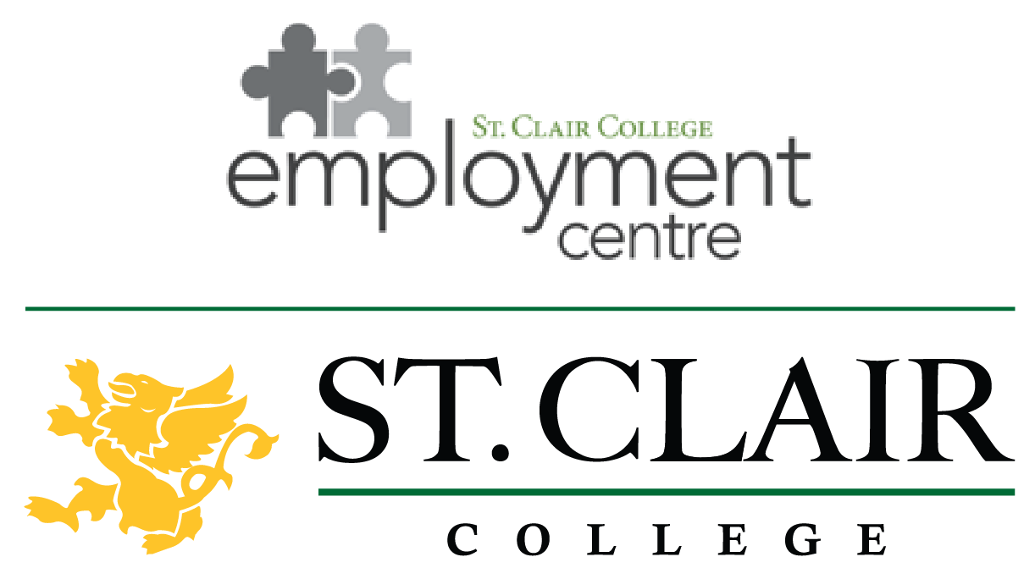  stclairemploymentcentre.com | FIRST LAST  Job Title,  Department  St. Clair College  youremail@stclaircollege.ca  Office: 519-972-2727 ext. xxxx  ROUNDHOUSE CENTRE  3015 Howard Avenue, Unit 2 | Windsor, ON N8X 3Y9
Please note you may add mobile if required.
stclairemploymentcentre.com | FIRST LAST  Job Title,  Department  St. Clair College  youremail@stclaircollege.ca  Office: 519-972-2727 ext. xxxx  Mobile: 519-000-0000  ROUNDHOUSE CENTRE  3015 Howard Avenue, Unit 2 | Windsor, ON N8X 3Y9

St. Clair College Employment Centre – Amherstburg
stclairemploymentcentre.com | FIRST LAST  Job Title,  Department  St. Clair College  youremail@stclaircollege.ca  Office: 519-972-2727 ext. xxxx  FORT MALDEN PLAZA  400 Sandwich Street South | Windsor, ON N9V 3L4
Please note you may add mobile if required.
stclairemploymentcentre.com | FIRST LAST  Job Title,  Department  St. Clair College  youremail@stclaircollege.ca  Office: 519-972-2727 ext. xxxx  Mobile: 519-000-0000  FORT MALDEN PLAZA  400 Sandwich Street South | Windsor, ON N9V 3L4

St. Clair College Employment Centre – Wallaceburg
stclairemploymentcentre.com | FIRST LAST  Job Title,  Department  St. Clair College  youremail@stclaircollege.ca  Office: 519-972-2727 ext. xxxx  COUNTY FAIR MALL  60 McNaughton Avenue | Wallaceburg, ON N8A 1R9
Please note you may add mobile if required.
stclairemploymentcentre.com | FIRST LAST  Job Title,  Department  St. Clair College  youremail@stclaircollege.ca  Office: 519-972-2727 ext. xxxx  Mobile: 519-000-0000  COUNTY FAIR MALL  60 McNaughton Avenue | Wallaceburg, ON N8A 1R9

